Subject: Analysis of Brand Performance and Data Quality Issues

Hi [Recipient's Name],

I wanted to share some key insights and challenges from my analysis of dataset provided for analysis.

Key Data Quality Issues:

* Missing UID-barcode mappings: This hinders accurate linking of transactions to users or products.
* Incorrect data formats: Sales data is sometimes stored as text, and timestamps are inconsistent, complicating trend analysis.
* Data discrepancies: The overlap between receipts scanned and total sales data appears inconsistent, requiring validation.

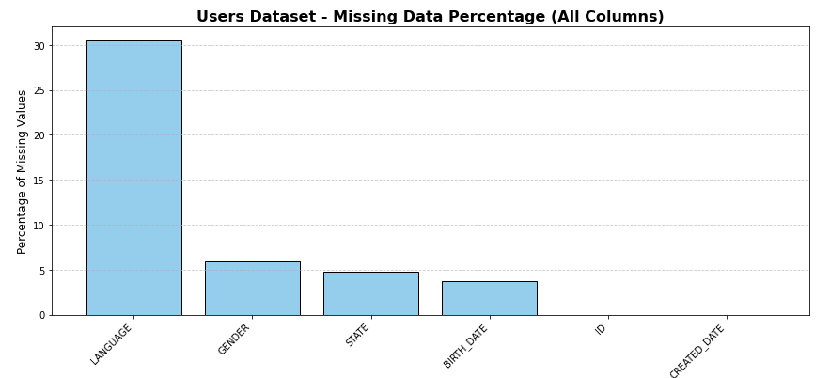 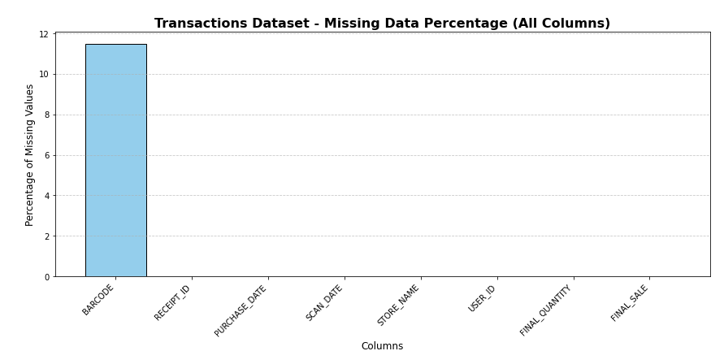

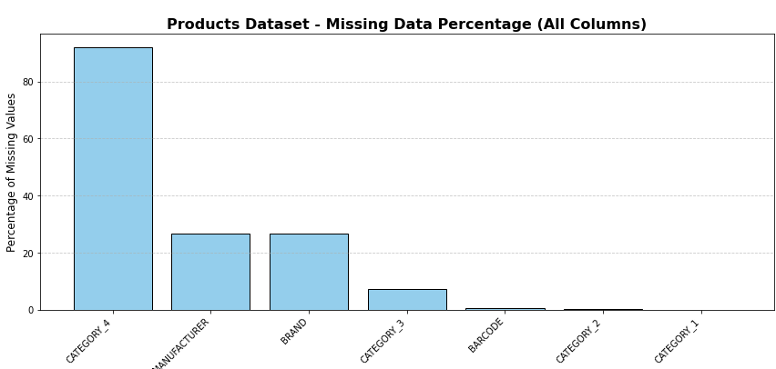

Interesting Trend:

The data shows a clear segmentation of brand performance:

* DOVE and SUAVE perform well in both receipts scanned and total sales, appealing to a broad audience.
* NERDS CANDY and TRIDENT are high in receipts scanned but lower in sales, indicating frequent small purchases.
* PEACH SLICES and PEACH & LILY lead in total sales despite fewer receipts scanned, suggesting their premium positioning.

Request for Action:

* Updated UID-barcode mappings to fill in missing data.
* Support from the data team to address formatting issues (e.g., sales figures and timestamps).
* Context on user segmentation or bundling strategies to better understand and validate the trends.

Please let me know if we can prioritize this or set up a quick meeting to discuss.

Regards,  
Kalpana Sharma